Terraform Task
Task Description:
Launch Linux EC2 instances in two regions using a single Terraform file.
=======================================================================
Steps: -

- Download Terraform in your local machine (Windows)
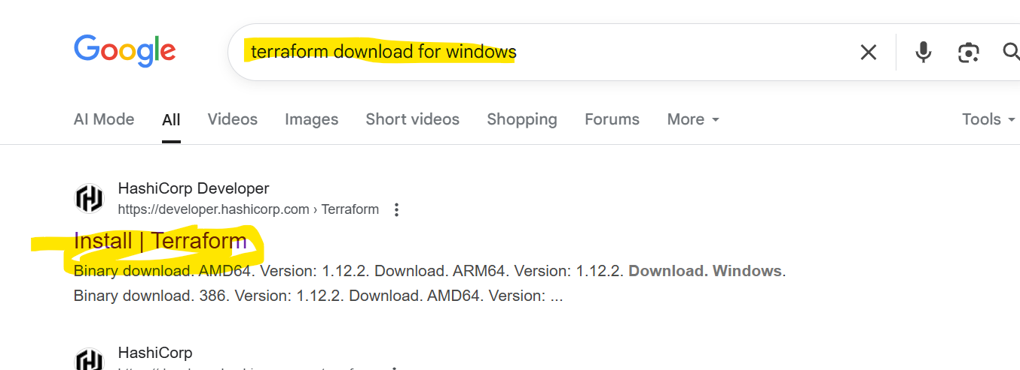

- For Windows -> Download highlighted package.

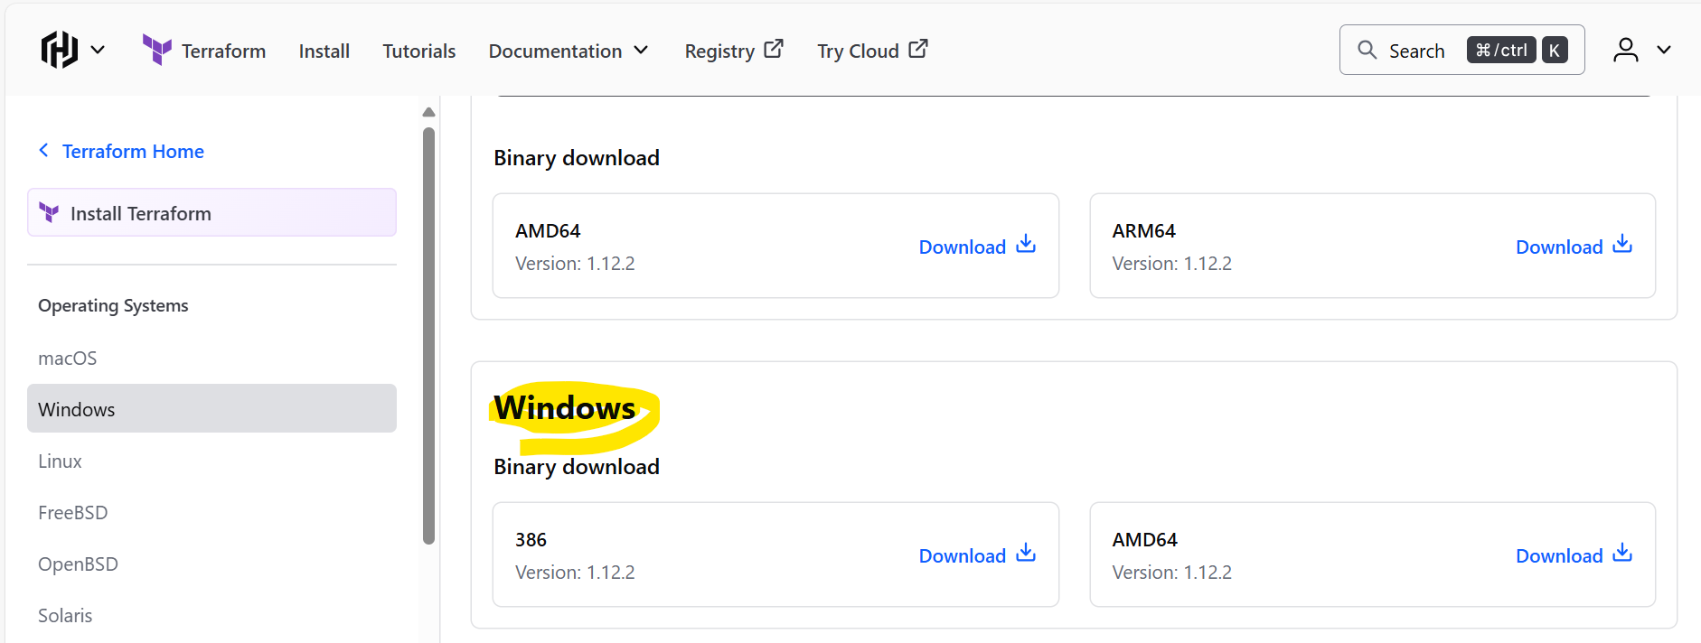

- Terraform is downloading in local machine (Windows)
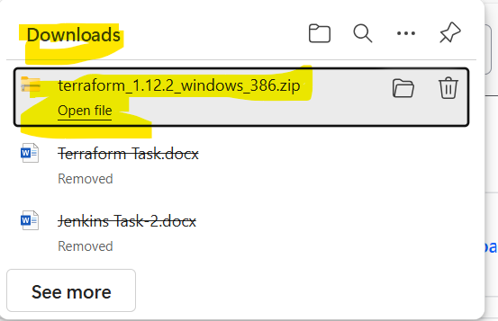
- Once downloaded, Extract the folder
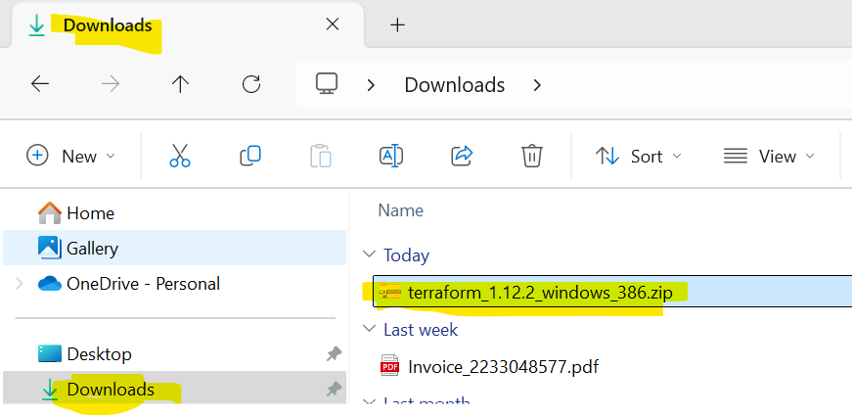

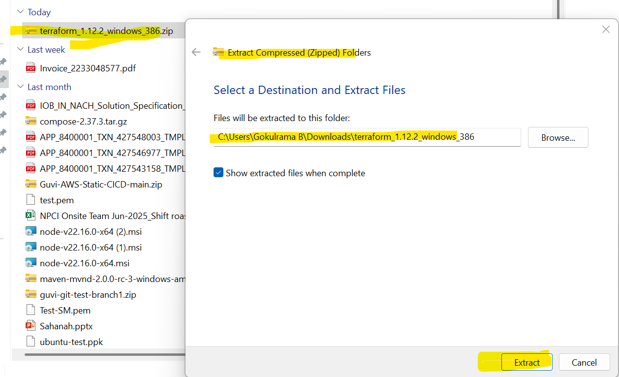

- Post Extracted folder, two files are there. One is Application and another file is license file

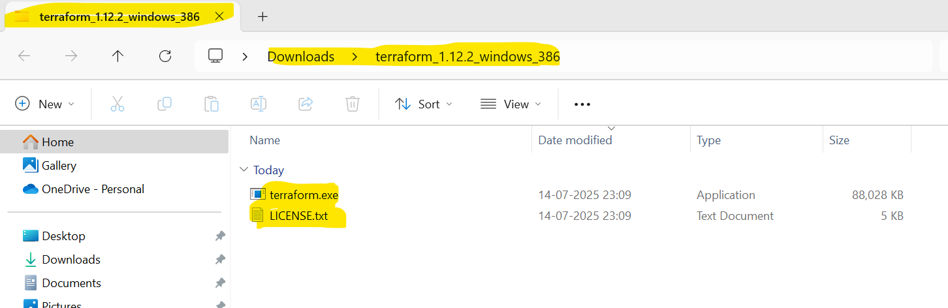

- Create a new folder in C: location and name the folder as Terraform

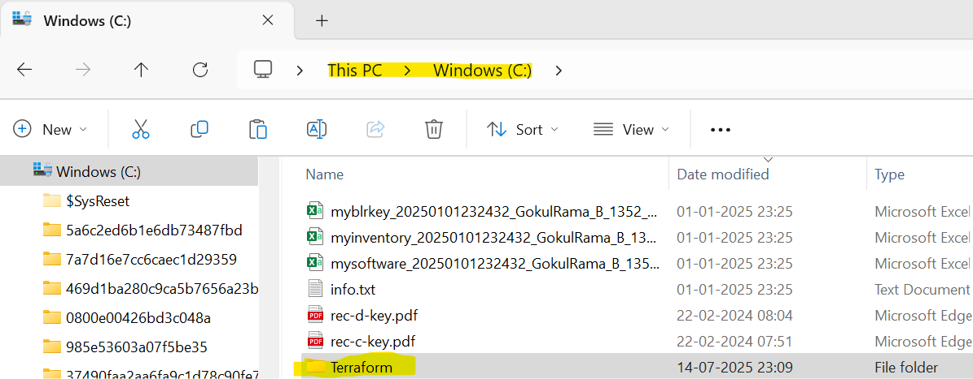

- Paste the above extracted files in newly created Terraform folder in C: location.

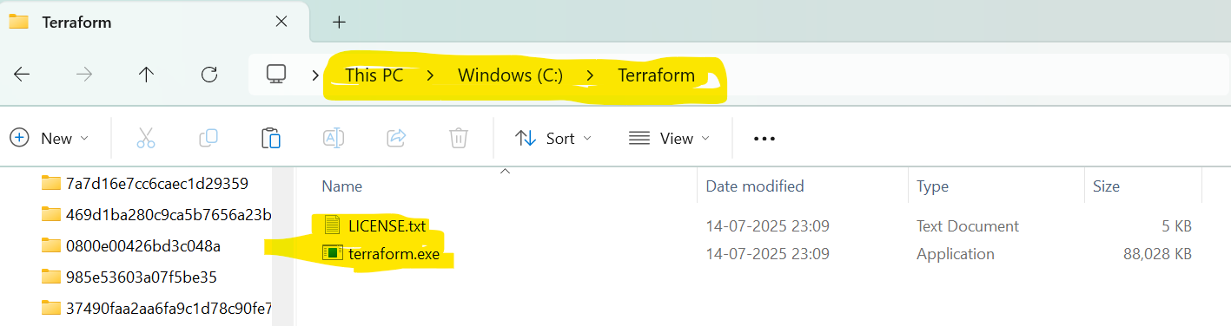

- Need to update System variable,
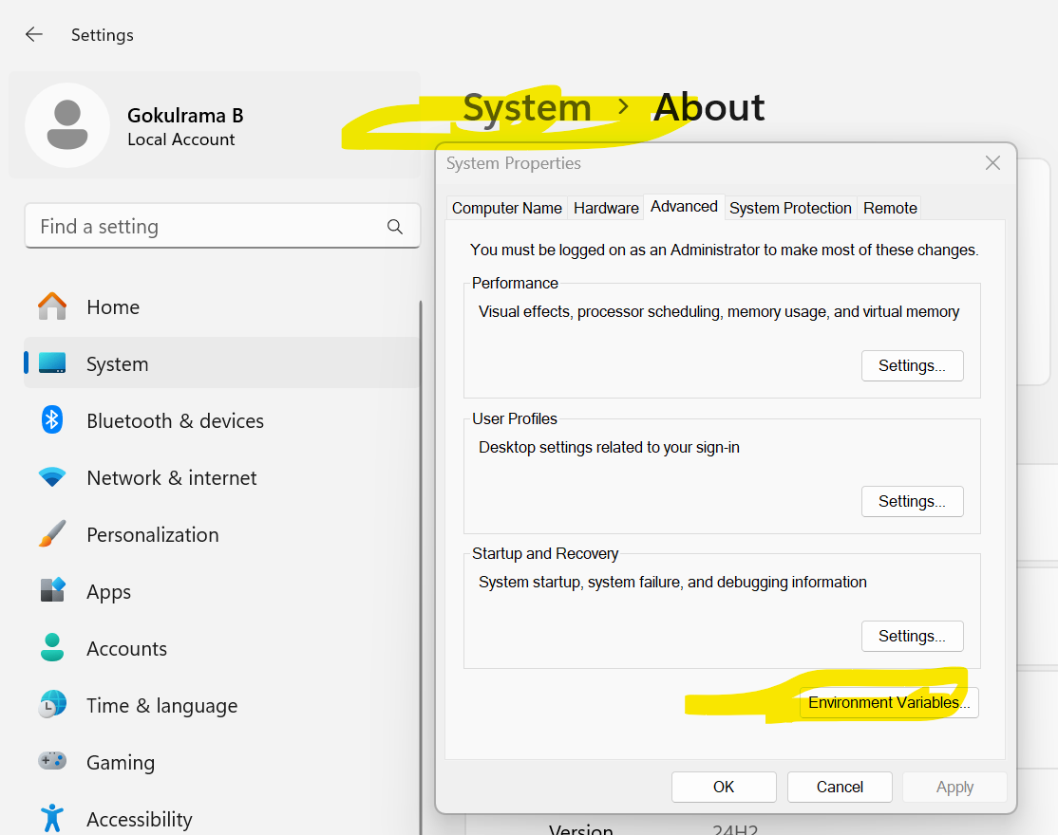

- Edit the system variable in User variable -> Path
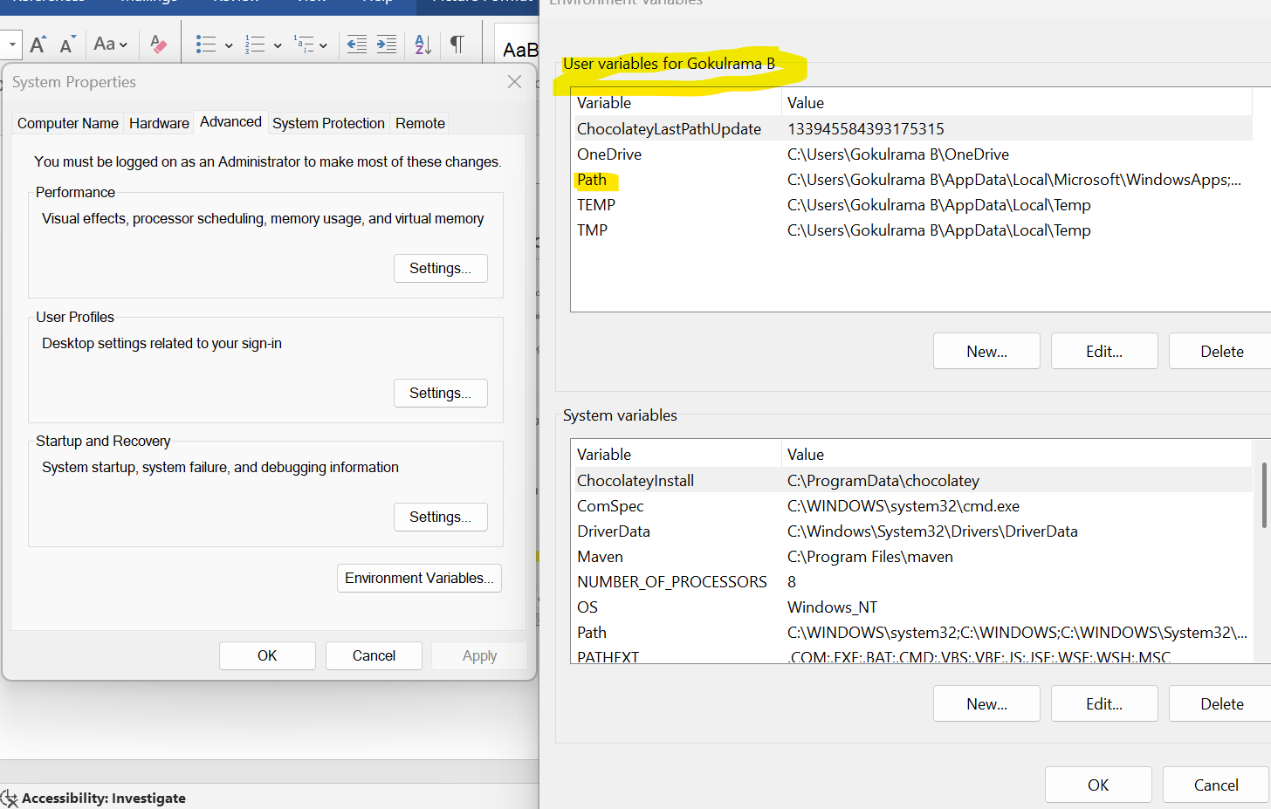

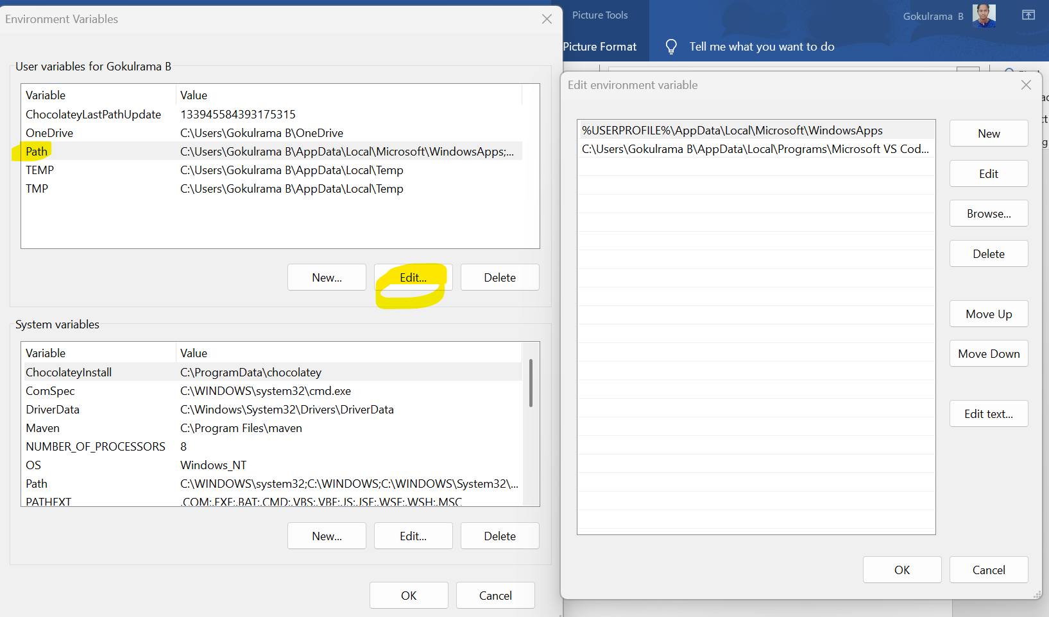

- Click New and add the below in environment and click ok
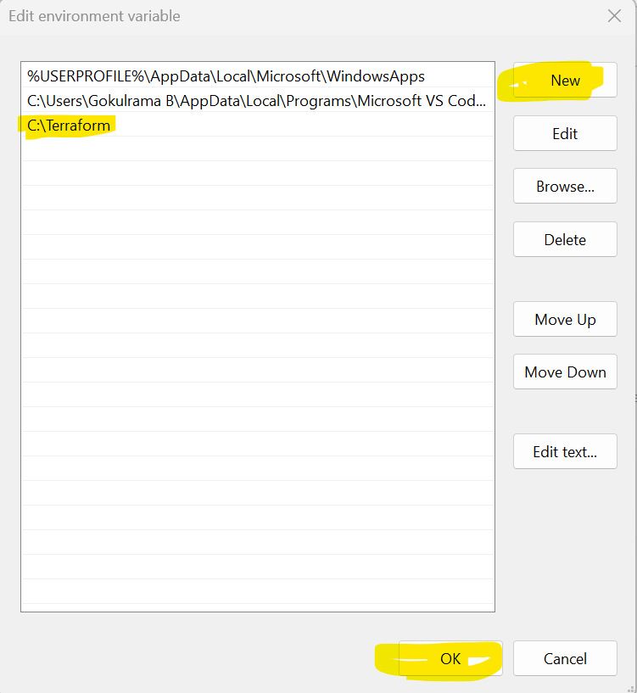

- In Same Environment Variable, Go to system variable -> Path -> Click Edit
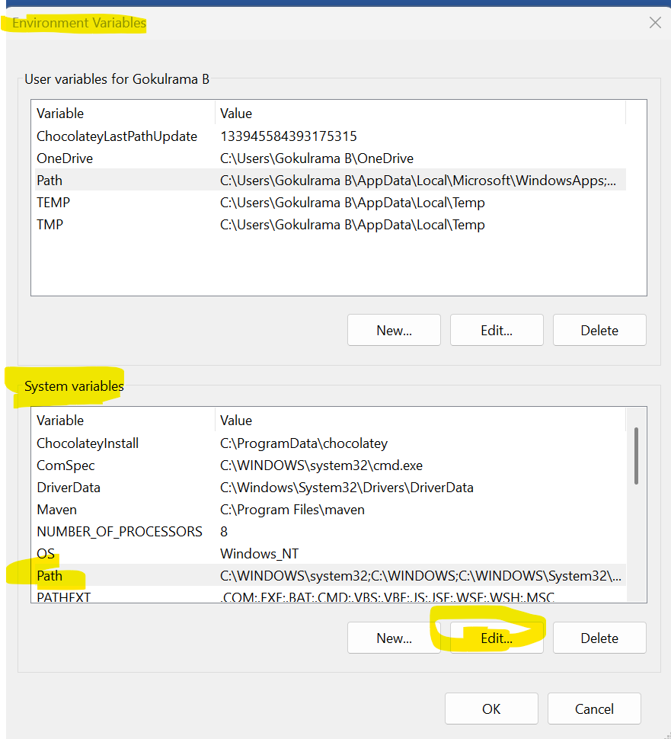

- Click New and do the below highlighted changes and click ok
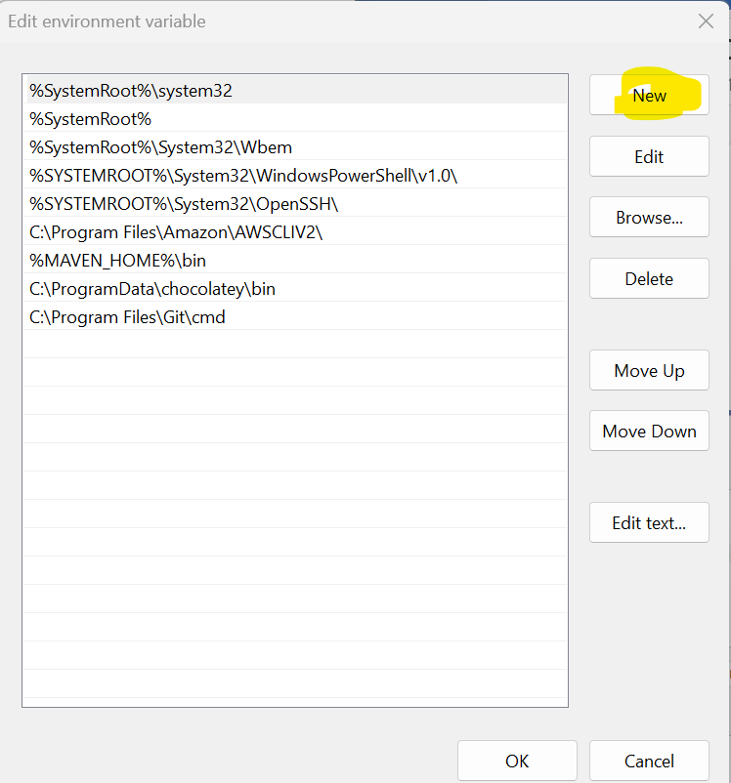

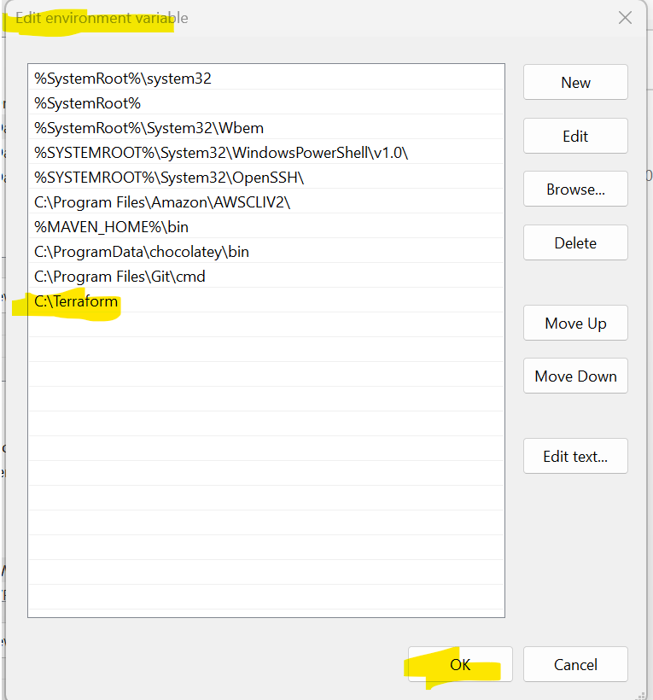

- Go to Visual Studio -> Select Terraform folder location created in C: drive
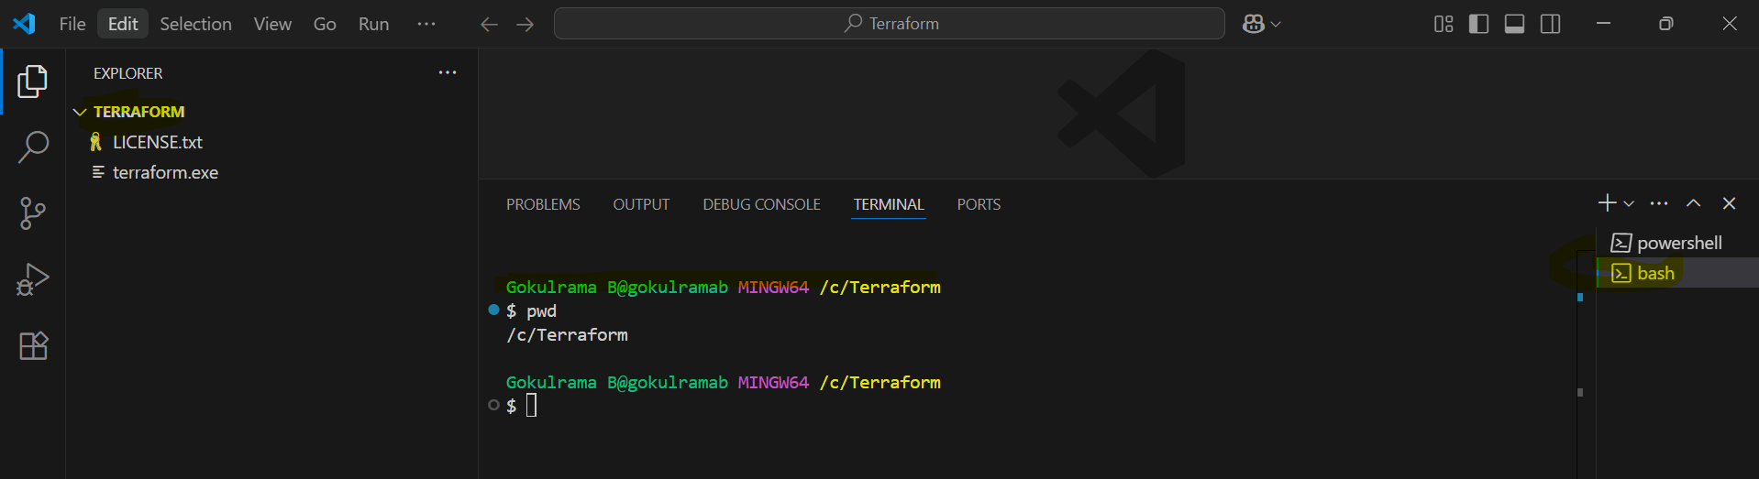

- Initialize Terraform and command is terraform -v (You get the terraform version by using this command)
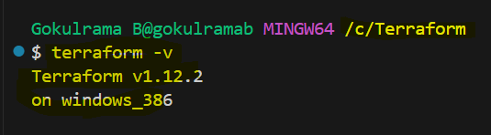

- Need to configure AWS CLI: -
- Command to configure AWS CLI is aws configure
- Enter Access Key ID and Secret Access Key
- Region name and Output format -> Just Enter
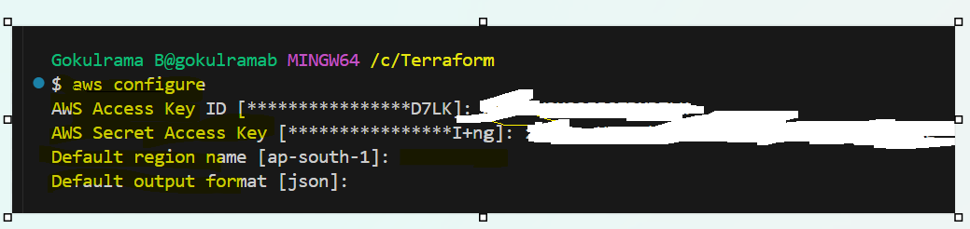

- Create new folder inside C: drive
